

**Icecream**

**Language: ENG**

|  |
| --- |
| **Confidentiality Notice**  *Use or disclosure of information contained in this document is subject to the restriction contained below.*  This document contains information proprietary & confidential to XIUS. It shall not be duplicated, used or disclosed in whole or in part for any purpose. Any disclosure, reproduction, duplication, transmittal or distribution of this document in whole or in part, using physical, electronic or any other media, requires written consent from an authorized XIUS signatory. |
|  |

**Disclaimer**

XIUS Product Services and Features all those defined in this document are configurable and would be enabled based on the mutual agreement between XIUS and the Customer in accordance with the Product License availed by the customer

**Revision History**

|  |  |  |  |  |  |  |
| --- | --- | --- | --- | --- | --- | --- |
| Document ID | | | Icecream Manual | | | |
| Document Title | | | Icecream Manual | | | |
| Ver. No. | Date | Revisions made | | Prepared By | Reviewed By | Approved By |
| 1.0 | 25th September 2023 | Initial draft docs | | Tech Publications |  |  |
|  |  |  | |  |  |  |
|  |  |  | |  |  |  |
|  |  |  | |  |  |  |
|  |  |  | |  |  |  |

**Table of Contents**

**No table of contents entries found.**

**PDF Editor**

* A PDF editor allows you to edit and manipulate Portable Document Format (PDF) files. With a PDF editor you can make changes to a PDF document, for instance adding or deleting text, images, and pages, modifying the formatting and layout, adding annotations and comments.
* UPDF is the best free PDF editor for Android as it is completely free, and you can easily modify documents and share them via email hassle-freely.
* Icecream PDF Editor has a free version and offers a free trial. Icecream PDF Editor paid version starts at US$49.95/one-time.

**Features**

1. Access controls/permissions.
2. Annotations: Add notes, underline, strikethrough and highlight text, leave comments using arrows, freehand and other shapes, add stamps and more.
3. Commenting/Notes.
4. Convert to PDF.
5. **View and edit PDF:** Use the free PDF editor daily as a PDF reader and edit or annotate your documents when needed. Do all that like a PRO in no time with the help of intuitive UI.
6. **Edit text and objects:** Icecream PDF Editor for Windows can perfectly edit all the commonly used PDF objects including text, images and shapes. Edit contents, change style, position, resize, rotate and delete objects.
7. **4 PDF editing modes:** PDF editor has 4 main PDF editing modes: Edit PDF, Annotate, manage pages and fill in forms. Each mode provides an exceptional set of tools.
8. **Free PDF editor:** Free version of the product is available with a few limitations. You can find the list of PRO features on the Upgrade page.

**Video Editor**

* Create fancy videos with no fuss. Add music, text, transitions, trim, crop and merge videos, tune colors, change speed and much more.
* Video Editor offers comprehensive support for a wide range of popular video and image formats, including but not limited to MP4, AVI, WEBM, MOV, JPG, PNG, GIF, and more.
* All main features are available in the Free version of Icecream Video Editor.

**Features**

1. Cut and split videos. Video editor by Icecream Apps provides the options to change the original video length.
2. Add audio to the video.
3. Add text to video.
4. Change speed.
5. Resize and crop videos.
6. Flip and rotate videos.
7. Voiceover.
8. Subtitles.
9. **Simple video editor:** Video Editor offers comprehensive support for a wide range of popular video and image formats, including but not limited to MP4, AVI, WEBM, MOV, JPG, PNG, GIF, and more.
10. **Supported formats:** Video Editor offers comprehensive support for a wide range of popular video and image formats, including but not limited to MP4, AVI, WEBM, MOV, JPG, PNG, GIF, and more.
11. **Quick sharing:** Upload your videos to the cloud. Share links to your projects with friends, colleagues and others. Track views.
12. **Fancy transitions:** Select from 20+ transitions for videos and 10 motion effects for photos. Use the 'Random' option for a one-click blend of these features.
13. **Windows video editor:** Icecream Video Editor supports the main Windows OSs including the latest Windows 11 and, of course, Windows 10.
14. **Free video editor:** The Free version of our software offers most video editing features, without adding watermarks to short videos. Explore our free video editor to learn more.

**Video Converter**

* Convert video files to various video and audio formats. Use presets to neatly convert for a specific device, ratio, or resolution.
* Icecream Video Converter is a free video software that lets you easily convert your video files into different formats. Developed by Icecream Apps, this multimedia program has a user-friendly interface for both beginners and advanced users and allows for offline file conversion whenever.
* Icecream Video Converter is available absolutely **free of charge**. No limitations, and no ads. You can also add your own watermark (images or text), add subtitles, trim videos, and mute them.

**Features**

1. **Bulk Conversion:** Add multiple files to the converting queue to change format of your videos in a bulk in just a single click. Apply output settings to all files if needed. Converting videos one by one is still available.
2. **All Popular Formats:** Video Converter supports all the most popular video formats: MP4, AVI, MKV, 3GP, WMV, MOV, M4V, MPG, M2TS, MTS and others.
3. **Device Presets:** Not sure about the format, resolution or other settings for the output file? Convert your videos according to the built-in presets (iPad, iPhone, Android, PS5, etc.).
4. **Trim Videos:** If you only need to convert part of a video, there's no need to install additional video editing software. Cut the video directly in the video file converter GUI and select a specific scene to convert.
5. **Conversation History:** All the previously converted files are conveniently stored in the 'History' section of the program. Manage your conversions like a pro.
6. **Add Watermark:** Easily add a custom watermark to your output videos. Use an image or text as a watermark, set its size, transparency, angle and more.

**Screen Recorder**

* Record screen and take screenshots. Share instantly. Add webcamera, draw on screen, schedule recordings, record audio, etc.
* Icecream Screen Recorder is a solution that allows businesses to record and edit videos using screen recording tools. With Icecream Screen Recorder, users can record online content including tutorials, online meetings, games, plus more.
* Icecream Screen Recorder has a free version and offers a free trial. Icecream Screen Recorder paid version starts at US$29.95/one-time.

**Features**

1. **Record Screen:** Whether you want to record your entire screen or just a specific area, our screen recording software makes it effortless. You have the flexibility to capture any monitor on your PC, and it's never been simpler.
2. **Annotate and edit records:** Enhance your screen captures by drawing, adding text, arrows, and bullet annotations. Our screen recorder also offers easy video editing features like trimming, adjusting playback speed, muting, and much more.
3. **Share instantly:** Record your screen with a single click and seamlessly upload the video to our servers. Share it instantly with colleagues or clients. Plus, keep track of your recording views right within the app.
4. **Windows 10 support:** Our software perfectly supports all main Windows OSs including Windows 11. However, the latest rebuilds and optimization make it the best Windows 10 screen recorder.
5. **Free screen recorder:** There are lots of screen recording features available for free. You can upload all recorded videos for sharing for free as well, no registration needed.

**PDF Split and Merge**

* Icecream PDF Split & Merge is a versatile application for splitting and merging PDF files in a quick and easy way. The program offers several convenient split modes that let users successfully complete different types of splitting tasks.
* Split PDF and merge PDF using single software. All the most essential settings to improve the productivity of working with PDFs.
* IceCream PDF Split and Merge is a free application that lets you split PDF files into multiple documents, or merge several of them into one document.
* Free method to PDF split and merge, no watermark.

**Features**

1. **Consequent PDF split and merge:** Split PDF into multiple files and then immediately combine them to merge into a new single PDF document if needed. All that in just a few clicks.
2. **3 modes of PDF splitter:** Divide your documents in three ways with PDF Split and Merge software: split PDF into single-page files, split PDF by groups of pages, remove unneeded PDF pages.
3. **No internet needed:** Icecream PDF Split & Merge processes files directly on your computer. No files are uploaded to our or third-party servers. This increases the reliability and the speed of PDF split and merge processes.
4. **Free PDF splitter:** Enjoy the best offline software for managing PDF documents. Free method to PDF split and merge, no watermark.
5. **Easy to use:** GUI of the software is simple and intuitive. Drag & drop PDF files to add them to the program. Merging and splitting PDFs has never been easier.

**Photo Editor:**

Meet Icecream Photo Editor - the best free photo editor and photo manager for Windows. Edit your pictures like a pro: add text and images, crop and resize, add filters, create collages and more with ease.

**Pricing:**

Free to Use and Ad-Free

**Features:**  
**Free photo editor**

Icecream Photo Editor is a free photo editing software. Draw, add stickers, blur, add frames, flip and rotate, crop and resize, etc.

**Supported image formats**

With Icecream Photo Editor one can edit photos and pictures of the most popular formats: JPG, JPEG, PNG, GIF, TIFF and BMP.

**Photo manager**

With Icecream Photo Editor you can easily organize the photos on your computer. Quickly browse through images in folders, rotate them if necessary, or delete unwanted ones.  
Simple photo editor

One of the main advantages of our image editor is its amazing ease of use. Everything you need is always at your fingertips, nothing unnecessary. There is no need to study manuals.

**Windows 11 supported**

This program works on all major Windows systems, including 11 and 10. Combined with its features and simplicity, this makes it the best photo editor for Windows.

**Add text to photo**

Adding text is easy when you use the Icecream Photo Editor. You can control all the basic parameters - font, size, weight, colors, opacity, etc.

**Resize and crop**

When editing photos, the most frequently used functions are "Resize Image" and "Crop Image". That’s why we've tried to make them as intuitive as possible.

**Add filters and stickers**

Pick one of the cool filters to enhance your photo: black and white, old film, fisheye, watercolors, and more. Add stickers from our library to make it even better.

**Rotate and flip images**

Rotate or/and flip your photos in a few clicks with our image editor.

**Image enhancement**

Use automatic image enhancement to instantly improve your photo. Or use one of the image settings to adjust the image the way you want it.

**Blur photos**

Easily blur images where needed to give them an artistic touch or hide sensitive data.

**Add frames to photo**

The free photo editor offers a variety of frames that you can easily add to pictures in a few clicks.

**Collage maker**

Use one of the many collage presets and create great photo content in a minute.

**System Requirements:**

**OS**

Windows 11, Windows 10, Windows 8.1, Windows 8, Windows 7

**Processor**

Intel®, AMD or any other compatible processor, 2.66Ghz

**Ram**

4GB of RAM minimum (16GB for better performance)

**Display resolution**

1024x768 minimum

**Disk space**

100MB - 5GB

**Languages**

English, French, German, Spanish, Italian, Portuguese, Russian, Traditional Chinese

**EPUB Reader:**

Meet easy-to-use free EPUB reader for Windows to read eBooks in EPUB, MOBI, PDF and other popular formats. Enjoy books in full screen with Icecream Ebook Reader.

**Pricing:**

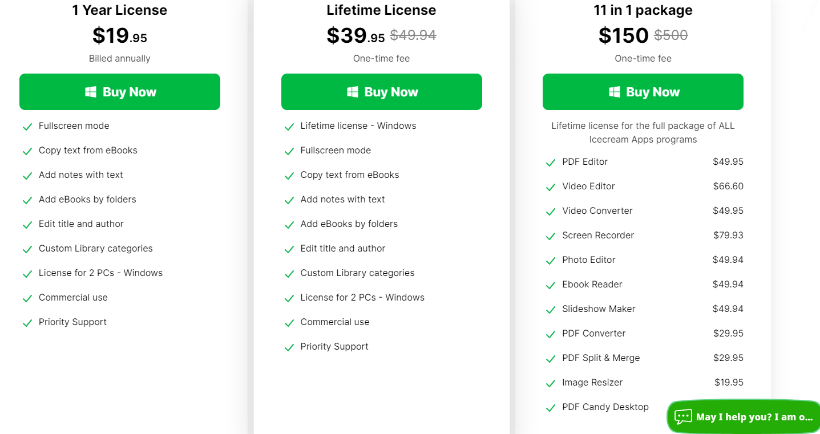

**EPUB Reader’s main features:**

**Supported eBook formats**

Not just an EPUB reader. The software also enables you to read books of other formats: MOBI, PDF, FB2, CBR, CBZ, TXT and even ZIP. However, no DRM protected content is supported.

**Highlight and add notes**

Add notes or highlight text in eBooks of the major formats such as EPUB and MOBI. Search and sort your notes by text or color.

**Create your digital library**

Add books to the eBook reader without limits, categorize them, add to favorites, etc. Search the library, track reading progress, use bookmarks and much more.

**Windows 10 support**

Our reader supports all the main Windows OSs including Windows 11. We worked hard to make it the perfect, if not the best, Windows 10 EPUB reader.

**Free EPUB reader**

All the essential reading features are available in the free version of the eBook reader.

**Full-screen mode**

Make the most of your EPUB reader: press F11 to switch to full-screen mode instantly.

**Text to speech**

Our reader will convert text to speech from any eBook and read it aloud for you. Different voices are available according to your system’s settings.

**Search in eBooks**

Don’t get lost in your eBook. Use in-book smart search by text or a page number to find what you need in no time.

**Dark reading mode**

Reading and making notes must be still enjoyable even in dim light. That’s why we created a well-designed night version of the EPUB reader.

**Copy, Translate, Google Search**

Quickly select eBook text to copy it to clipboard, translate or search it on Google or Wikipedia.

**Customizable layout**

Adjust font family, font size, line space if needed. Set double- or single-page text layout.

**Slideshow Maker:**

Create impressive slideshows and video presentations with the free slideshow maker by Icecream Apps. Combine photos, add transitions, music, text and more. All in a simple way.

**Pricing:**

However, you can also choose to pay a one-time fee of $39.95 for a lifetime license.

**Features:**

**Slideshow with music**

Add background music in MP3, M4A or WAV format to your slideshow. Add a whole audio playlist if your photo slideshow is a longer one.

**Add text to slideshow**

Add text to the slides with the slideshow maker. Personalize your comments by adjusting font, color, animation, background color and position.

**Free slideshow maker**

You can perfectly create a great video from photos without watermark even in the Free version of the program. Upgrade to PRO if you are interested in the advanced features.

**Simple & friendly GUI**

What's the best about our slideshow software? It is really as simple-in-use as possible. Drag&drop images and audio, customize the default/bulk/random settings, sorting options will help you to effortlessly create a beautiful slideshow.

**All Windows OS supported**

Use our slideshow program on all Windows OSs: 7 to 11. Along with the intuitive interface and ease of use, it definitely makes our app the best Windows slideshow maker.

**Slideshow preview**

Preview the full photo slideshow or specific slides in the slideshow maker’s built-in player. Available instantly after making the changes.

**Set timing**

Set the duration of each slide and transition in seconds. Apply the needed timing for all the queued slides using the bulk settings.

**Add transitions**

More than 25 cool transitions to improve your slideshow: fade to black, zoom out, cross fade, flip over, checkerboard and more. ‘Random transition’ option is available.

**Resume slideshow projects**

Do you need to create a complicated long slideshow? Slideshow maker restores previous project at program's launch. Also, get back to any previously created slideshow and make changes to it from the ‘History’ panel.

**Sort slides**

Sort photos in a queue alphabetically or shuffle them in a random order with a single mouse click. And, of course, you can always sort and rearrange slides manually by dragging and dropping.

**Choose output resolution**

Easily create photo slideshows for Instagram and Facebook. You can even create a 4K slideshow in high resolution with the slideshow maker.

**Share easily**

Instantly upload your slideshow video to Google Drive, YouTube or Dropbox. Share your presentation easily with friends and colleagues.

Burn to DVD

Need a hard copy of your slideshow to watch it later on TV? Burn it to DVD with our free slideshow maker.

**Motion effect**

Add dynamic movement and visual effects to static images, transforming them into lively and engaging slideshow.

**Loop video**

Seamlessly repeat your slideshow's playback for a set number of times. Create a smooth and uninterrupted viewing experience.

**PDF Converter**

Meet free PDF converter by Icecream Apps. Convert to PDF format and vice versa in a bulk: PDF to Word, JPG to PDF, Word to PDF, Excel to PDF and much more.

**Pricing:**

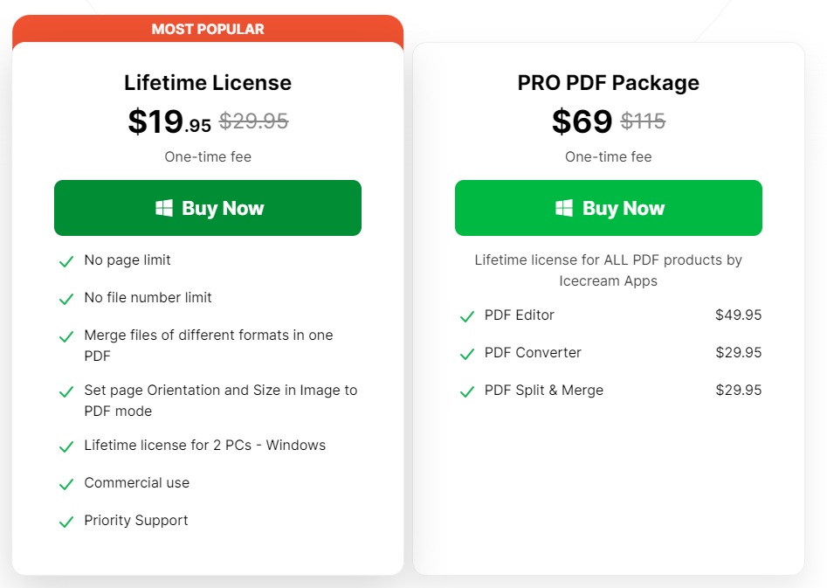

**PDF Converter features**  
**Convert to PDF**

Convert images to PDF (JPG, PNG, BMP, TIFF, BMP, GIF), spreadsheets (XLS, XLSX, ODS) and documents (DOC, DOCX, ODT, RTF) to PDF, eBooks to PDF (EPUB, MOBI, FB2) and HTML to PDF.

**Convert from PDF**

Convert PDF files to images (PNG, JPG, BMP, TIFF, GIF) or to editable DOC, DOCX, RTF documents. OCR (optical character recognition) included. Converting PDF to EPS and PDF to HTML are supported, too.

**Free PDF converter**

Free version of Icecream PDF Converter is available for everyone with just a couple of limitations. No watermark applied.

**Batch processing**

Add multiple files to form a queue with the PDF Converter. Convert to or from PDF as many files as you need at once. Optionally, you can merge files of different formats into a single PDF file.

**Privacy guaranteed**

Convert to PDF offline with our software. No need to upload your private documents with sensitive data. All files are stored and processed on your PC only.

**Convert large files**

PDF converter processes documents locally on your PC. This gives you the opportunity to process PDFs and convert to PDF files of any size.

**The best PDF converter**

Many years of experience in developing PDF converting and editing software allow us to provide you with the best solution on the market.

**Select page ranges**

Select specific PDF pages you want to be converted to images to increase productivity

**Layout settings**

Convert images to PDF an set the page orientation, margins and size; rotate content and select its position.

**Set password**

Set the password to protect created PDF documents. Processing protected files is supported, too.

**Built-in PDF preview**

Free PDF converter features a handy document preview. Use it to make sure you picked the right file or to select pages for conversion.

**Image Resizer**

Try our simple image resizer for Windows. Batch resize images in a single click and add a watermark. Resize images of any size! JPG, PNG and other formats are supported.

**Pricing:**

Icecream Image Resizer is a free and simple tool with preset profiles and GUI for easy and fast images resizing.

**Image Resizer features**

**Supported image formats**

With Icecream Image Resizer one can resize images of the most popular formats: JPG, JPEG, PNG, BMP, GIF and TIFF.

**Batch resize photos**

Add as many pictures to the image resizer as you need. Adjust common output settings and shrink photos in a bulk. No file number limitations.

**Simple image resizer**

Drag&drop images you want to resize into the program window, choose one of the size presets and press the ‘Resize images’ button. It’s that simple.

**Windows 10 and 11 supported**

This software is specially designed for Windows systems. It supports all OS versions - from XP to 11. Download and enjoy the best Windows image resizer on the market.

**Free image resizer**

The major features of the program are available for free. Upgrade Icecream Image Resizer to PRO version to experience unlimited batch resizing of images.

**Size presets**

Batch resize images for email, Facebook, Twitter, Instagram and more. We got it all covered. Still, you can always set the output dimensions manually.

**Resize by whole folders**

Add files one by one or add a whole folder with photos at once to the free image resizer’s queue to get maximum productivity.

**Add custom watermark**

Photo resizer that adds your own logo to the resized images. Protect the copyright or make the pictures look more professional.

**Vertical images recognition**

Image resizer detects vertical images and automatically inverses batch width and height settings for them.

**Final size estimation**

Before shrinking photos, check the overall estimated size calculated for the selected preset.

**Output settings**

Choose if you want to save result images into a specific folder, subfolder or overwrite the original files.